**Q9) The executed code;**

x=random('unid', 10,1,7);

h=random('unid', 10,1,7);

y=conv(x,h);

figure

stem(x);

figure

stem(h);

figure

stem(y);

**x[n]**

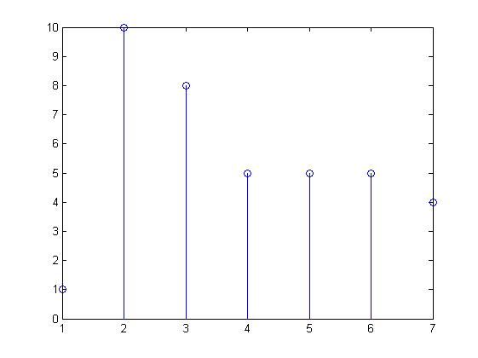

**h[n]**

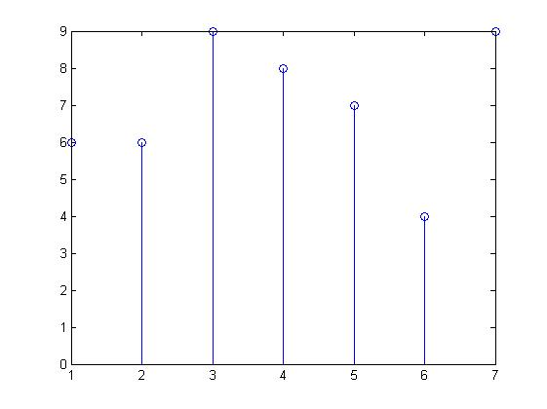

**y[n]**

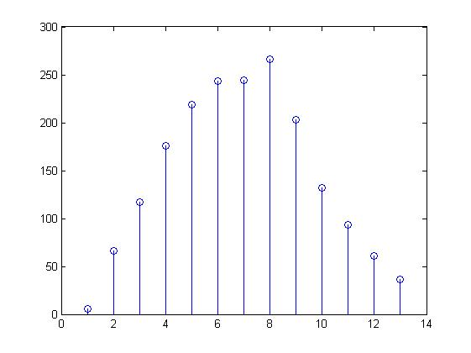

**The convolution is resulted as expected.**

**Q10)**

**a)**

%Take the coefficients of the polynomials as the vector elements.

p1=[23 45 21 67]; %23x^3+45x^2+21x+67

p2=[12 23 1 0 0 9]; %12x^5+23x^4+x^3+9

p3=conv(p1,p2); %p3 is the multiplication of p1 and p2

**The results is;**

p3 =

Columns 1 through 6

276 1069 1310 1332 1562 274

Columns 7 through 9

405 189 603

**b)**

y=[1 1 2 3 4 -1 5];

x=1:5;

h=deconv(y,x);

stem(h);

**and the result is;**

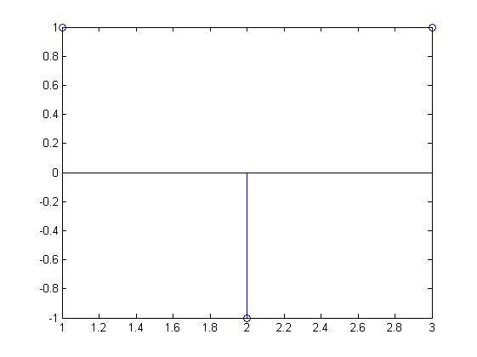

**We see that our computations are correct.**

**c)**

y=[1 2 2 3 4 -1 5];

x=1:5;

h=deconv(y,x);

stem(h);

**and the result is;**

